**Initial word frequency**

Word cloud and a bar chart showing what people are saying in their answer to this question

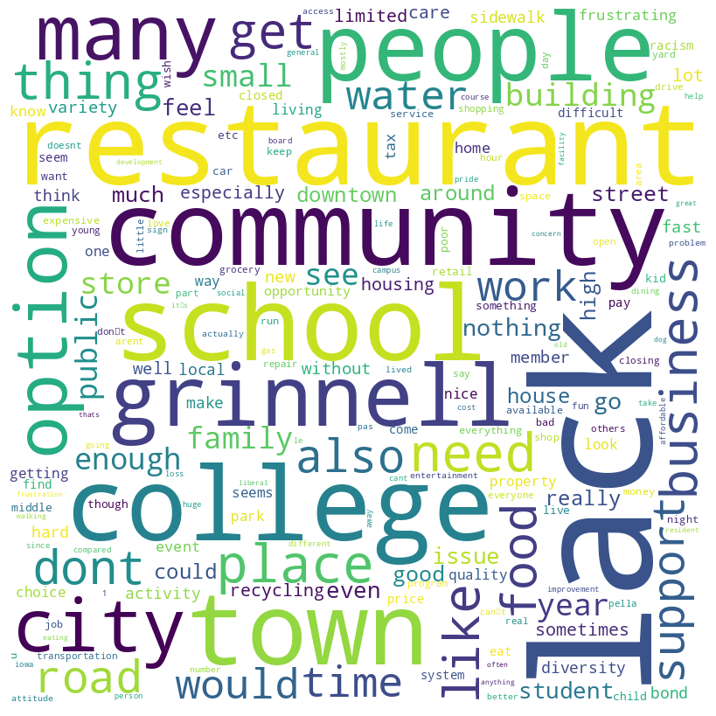

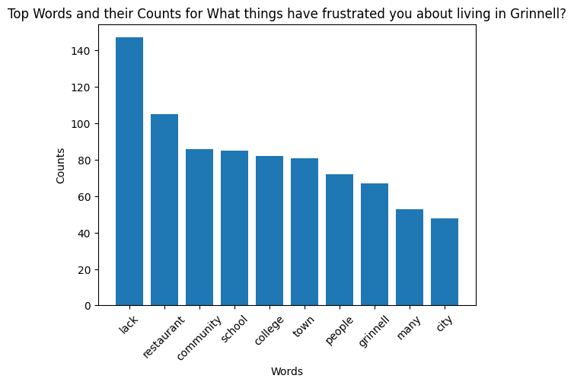

**Words before after a word**

Visuals highlighting words that appear after or before a certain word, in this case “lack”

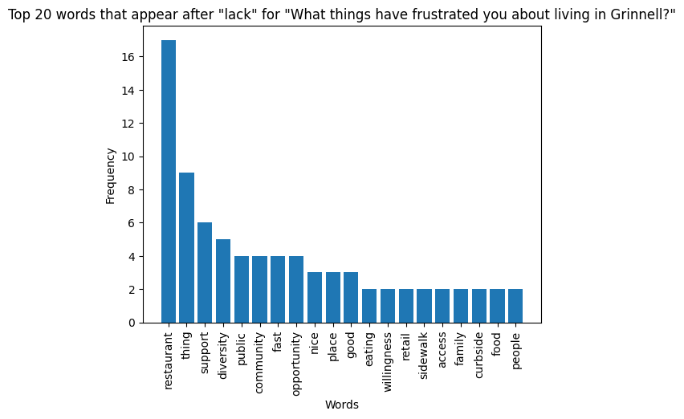

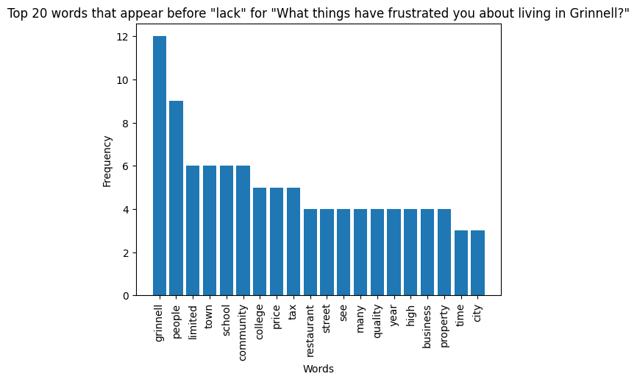

2 words after the word lack Excel file output snapshot:

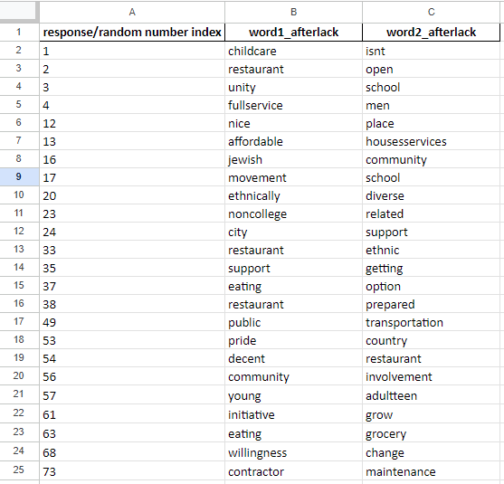

**For the full excel file, navigate to Final Deliverable > Individual Question Analysis & Deliverables > Words after common word > afterlack.xlsx (Excel file)**

**Sentiment Analsysis**

Numbers on how many people were positive, negative, or neutral in their responses.

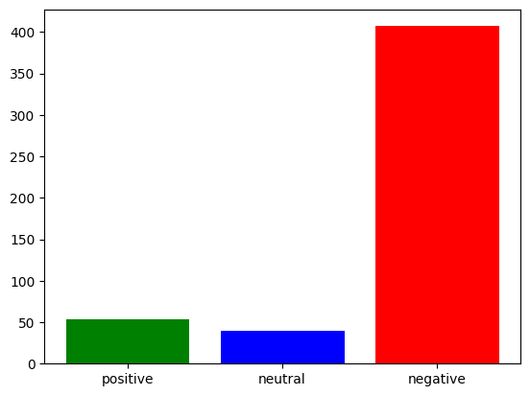

The number of **positive** statements is 53

The number of **negative** statements is 407

The number of **neutral** statements is 40

**Snapshot of which rows are in which category** (only part of the output):

